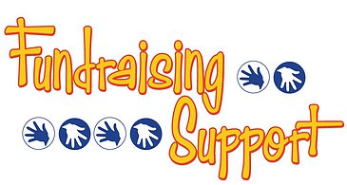
Each year we conduct a number of fundraising activities,
Fundraising is important as it allows us to maintain or purchase new equipment for our athletes as needed. It also allows us to offset some of the costs to keep tuition as affordable as possible for our current and prospective families. To keep things interesting, we strive to conduct activities that are enjoyable for our athletes and families. This year we will be hosting a Golf Outing on May 21st at the Captains Club in Grand Blanc and a Euchre Tournament that is in the planning stages. Our hope is that as many as possible will participate in these events, however if you are limited on time or maybe you’re not a golfer or euchre player but would like to still help out.
We have determined several gift basket themes that will be raffled off at either the Golf Outing or the Euchre Tournament. If you’re able we would appreciate support with donating the items listed to fill the baskets.
Thank you,
The Brandon Jr Blackhawks Board.
Date Night Gift Basket - https://www.signupgenius.com/go/30E0B4CA9A628A5FC1-fundraising6/
Wine & Cheese Basket - https://www.signupgenius.com/go/30E0B4CA9A628A5FC1-fundraising5/
Summer Gift Basket - https://www.signupgenius.com/go/30E0B4CA9A628A5FC1-fundraising4/
Chocolate Lovers Basket - https://www.signupgenius.com/go/30E0B4CA9A628A5FC1-fundraising3/
Sports Gift Basket - https://www.signupgenius.com/go/30E0B4CA9A628A5FC1-fundraising2/
Movie Gift Basket - https://www.signupgenius.com/go/30E0B4CA9A628A5FC1-fundraising1/
Liquor Gift Basket - https://www.signupgenius.com/go/30E0B4CA9A628A5FC1-fundraising/

